Implement following with forms

Login model class, component and template, display “ Login Success” if username and Password

Is innovapptive else display Login failure enter again.

Use event handling when Login button is clicked above message should be displayed below form.

When cancel button is clicked data should be cleared.

Implement 2 methods in component submit(),clear().

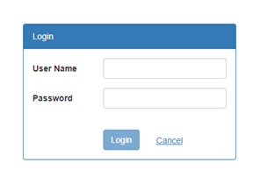

Response should be displayed below form.